
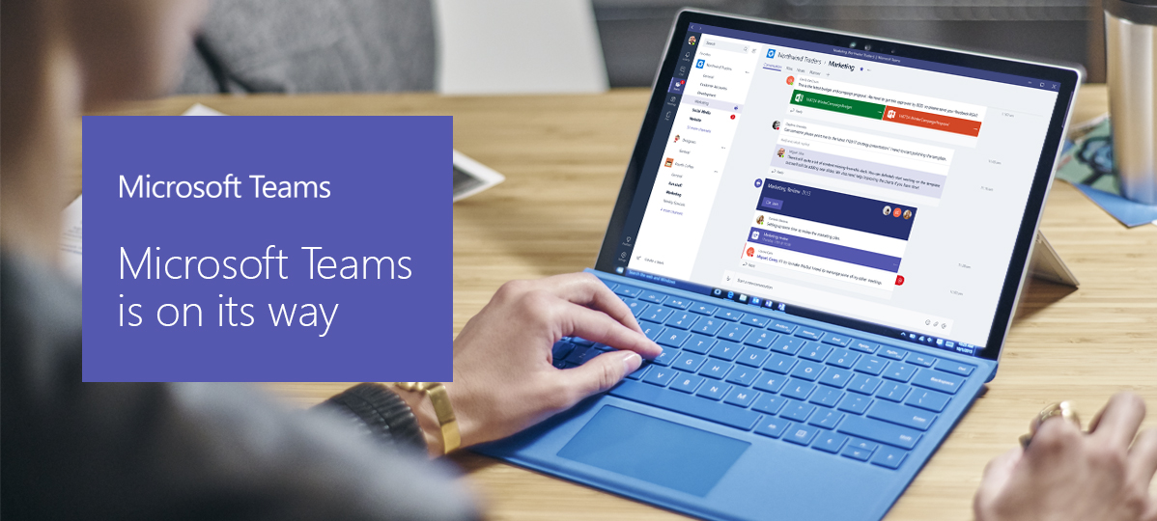
The new way for teams to work
On <fill in date> we’re rolling out Microsoft Teams, the chat-based collaboration workspace in Office 365. Give teams instant access to everything they need in a dedicated hub for teamwork where chat, content, people and tools live together in Office 365.
Watch the video

A hub for teamwork |  | 
Until now there hasn’t been one hub where people can chat, collaborate and share content with the teams they work with. Microsoft Teams changes that.

 | Meetings in moments
Going from group chat to call at the touch of a button means your teams are only a mouse click away from connecting for a productive, context-rich meeting.
Watch the video

Customizable for each team |  | 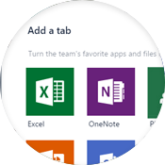
Tailor your workspace to include content and capabilities your team needs every day. Add Tabs to provide quick access to frequently used documents and cloud services like PowerPoint, Planner, SharePoint, and Power BI.

 |  | Join us on <fill in date> for tips on getting started  with Microsoft Teams.
  Learn more | 
 |  | Let us know your questions or thoughts about  Microsoft Teams.  <insert email alias or Yammer group link for company>

 | See what you can do with Microsoft Teams | Watch the product tour



